FUNDAMENTALS OF JAVA
basics of Java

Java is a programming language and a platform. Java is a high-level, robust, object-oriented and secure programming language.
Java was developed by Sun Microsystems (which is now a subsidiary of Oracle) in the year 1995. James Gosling is known as the father of Java. Before Java, its name was Oak. Since Oak was already a registered company, so James Gosling and his team changed the name from Oak to Java.

Difference between JDK, JRE, and JVM

JDK, JRE, and JVM are three components form the core of the Java platform and are closely related, but each has a distinct role in Java development and execution. Before learning Java in depth, it is important to understand the difference between JDK, JRE, and JVM. \

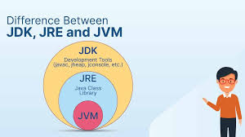

Difference Between C++ and Java

C++ is a powerful programming language that provides close control over system resources and memory management, whereas Java is designed to be simple, portable, and platform-independent. Let us understand the key differences between C++ and Java in different aspects such as memory handling, performance, platform dependency, and application areas.
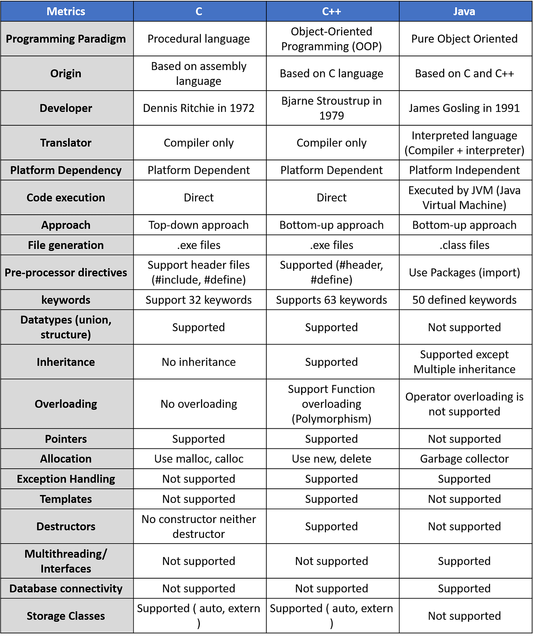

Data Types in Java
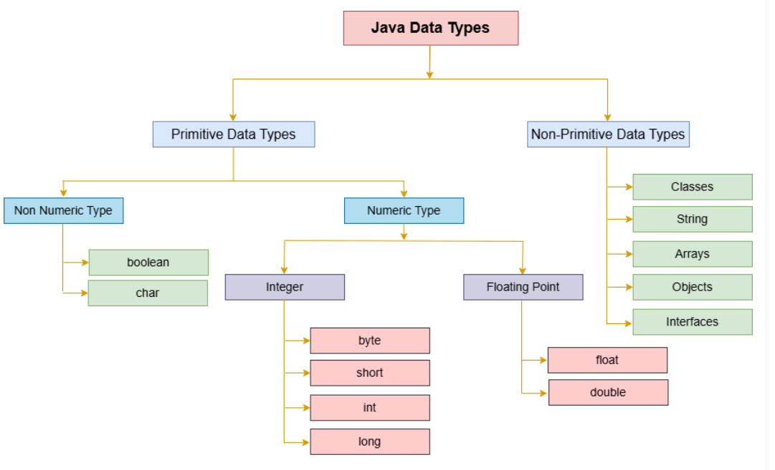

Application
According to Sun Microsystems, 3 billion devices run Java. There are various devices where Java is currently used. Some of them are as follows:
- Desktop Applications such as Acrobat Reader, media player, antivirus, etc.
- Web Applications such as irctc.co.in, tpointtech.com, etc.
- Enterprise Applications such as banking applications.
- Mobile
- Embedded System
- Smart Card
- Robotics
- Games, etc.

Types of Java Applications
There are the following 4-types of applications that can be created using Java programming:

1) Standalone Application
Standalone applications are also known as desktop applications or window-based applications. These are traditional software that we need to install on every machine. Examples of standalone applications are Media players, antivirus, etc. AWT and Swing are used in Java for creating standalone applications.

2) Web Application
An application that runs on the server side and creates a dynamic page is called a web application. Currently, Servlet, JSP, Struts, Spring, Hibernate, JSF, etc. technologies are used for creating web applications in Java.

3) Enterprise Application
An application that is distributed in nature, such as banking applications, etc. is called an enterprise application. It has advantages like high-level security, load balancing, and clustering. In Java, EJB is used for creating enterprise applications.

4) Mobile Application
An application that is created for mobile devices is called a mobile application. Currently, Android and Java ME are used for creating mobile applications.
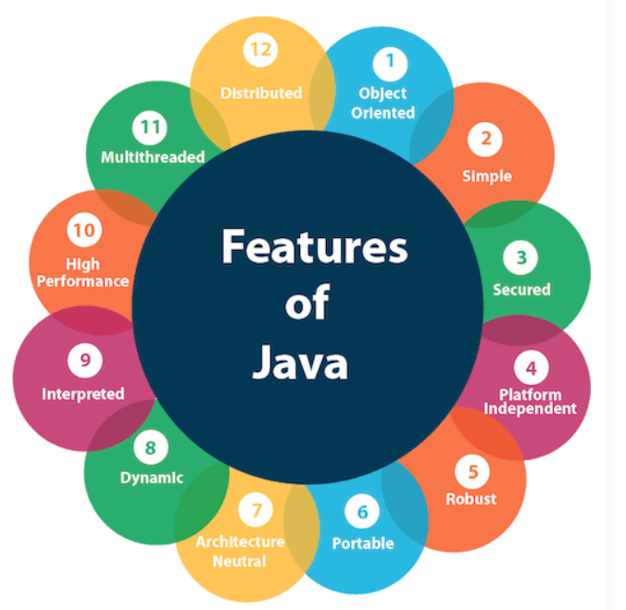

Object-Oriented
Java is an object-oriented programming language where everything is an object. Object-oriented programming means that we organize our software as a combination of various types of objects that incorporate both data and behavior.
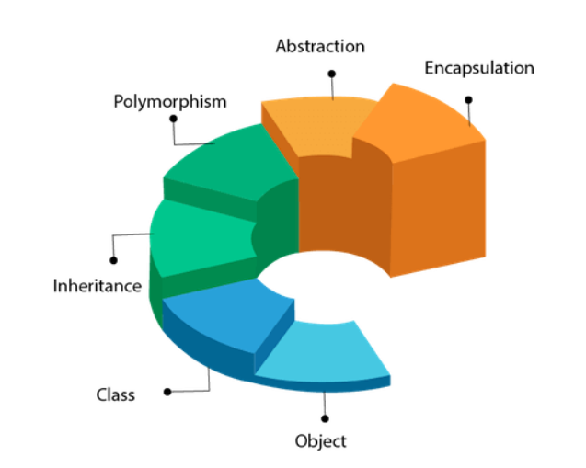

Java Classes and Objects
In object-oriented programming, classes and objects play a vital role in programming. These are the two main pillars of OOP (Object-Oriented Programming). Without classes and objects, we cannot create a program in Java. So, in this section, we are going to discuss about classes and objects in Java.

Java Class Syntax
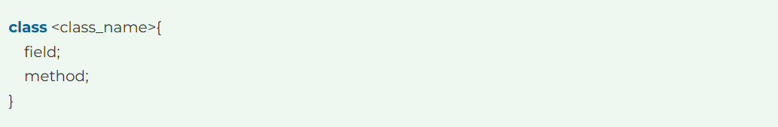

Syntax of an Object
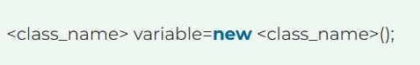
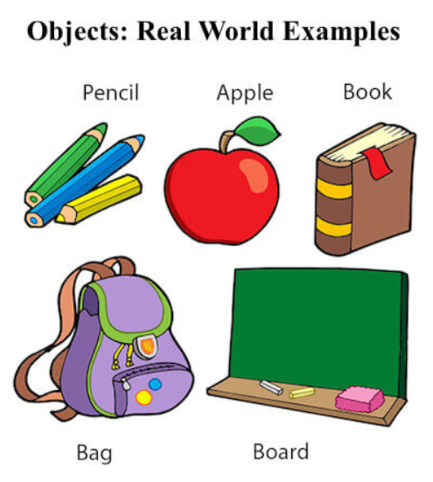
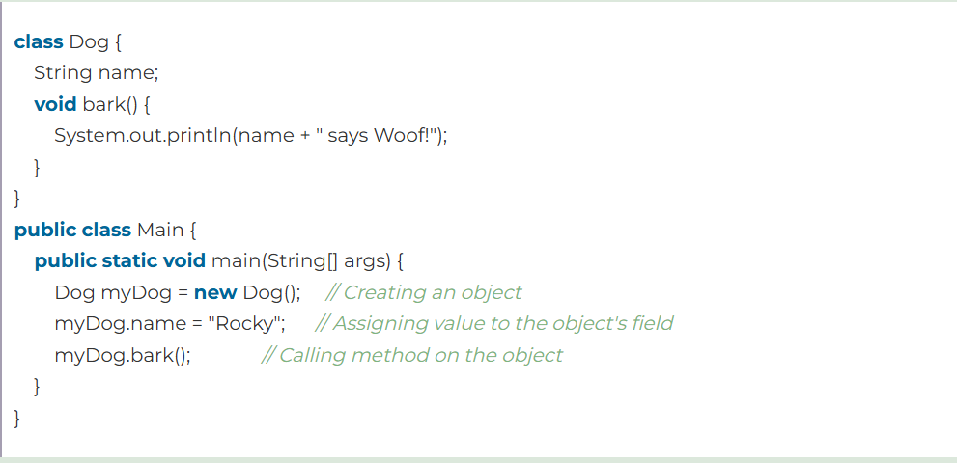

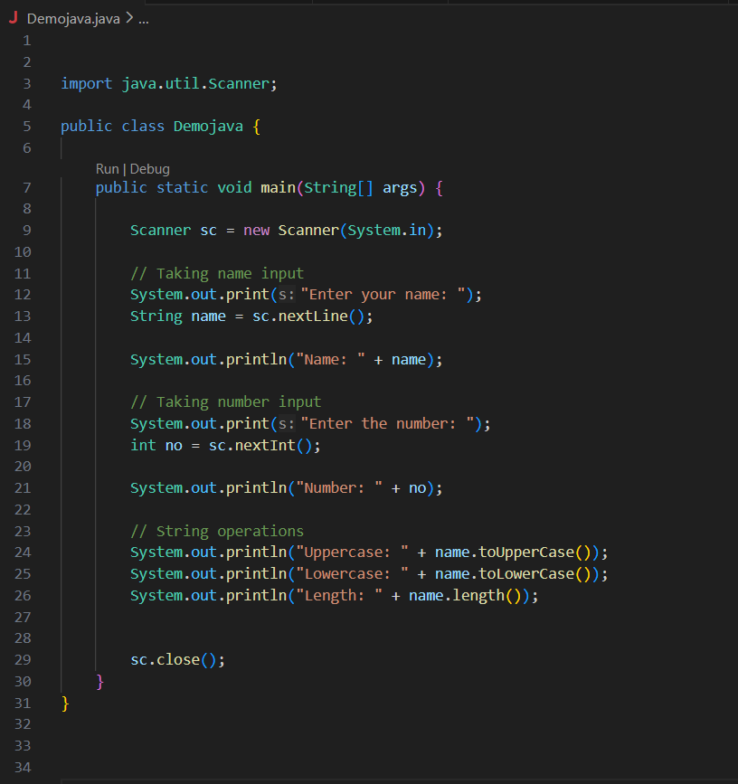
Name:-Nilesh Chavan
PRN:-202401110017
Name:- Harshad Dhokare
PRN:-202401110024

